Retail Store Sales Analysis
by: Himanshu singh

Executive Summary
- This analysis evaluates FashionWave’s sales performance across 50 stores to address stagnant weekend revenue.
- Key issues identified include low weekend transaction volume despite high customer spending, excessive discounting leading to profit loss, and category-level inefficiencies impacting overall performance.
- The analysis reveals a ₹19.36M profit loss due to discounting, a significant gap between weekend and weekday sales (0.52 ratio), and underperformance of the Clothing category despite high sales volume.
- Recommendations focus on targeted weekend strategies, optimized discounting, and customer segmentation to improve sales performance and profitability.

Business Objective
The primary objective of this analysis is to improve FashionWave’s sales and profitability using data-driven insights.
- Increase weekend sales by 15% by improving customer footfall
- Identify underperforming product categories and improve profitability
- Analyze the impact of discounting on margins
- Evaluate store-level performance to identify gaps
- Segment customers based on behavior for targeted strategies
Overall Goal:
To increase weekend revenue while improving profit margins through optimized pricing, product mix, and customer targeting.

Dataset Overview
The dataset fashionwave_sales.csv contains transactional sales data across 50 stores.
Key Features:
- Dataset Size: 15,000 transactions
- Business Scope: Retail fashion sales
- Granularity: Invoice-level (Transaction-level data)

Data Cleaning & Preparation
Handled missing values in Discount (%) and CustomerType
Ensured consistency in category and payment mode
Verified numerical fields (Quantity, UnitPrice, CostPerUnit)
Created Calculated Columns:
- Gross Sales = Quantity × UnitPrice
- Total Sales = Gross Sales × (1 - Discount %)
- Total Cost = Quantity × CostPerUnit
- Net Profit = Total Sales - Total Cost
- Profit Margin (%) = (Net Profit ÷ Total Sales) × 100
Assumptions:
- Discounts are capped at 30%
- Cost per unit remains constant across stores

Exploratory Data Analysis (EDA)

EDA was conducted to evaluate sales performance, profitability, and customer behavior using key KPIs.

Key KPIs
- Total Sales: ₹192.9M
- Average Order Value (AOV): ₹12,865
- Profit Margin: 72.5%
- Total Profit: ₹139.9M
- Units Sold per Category:
  - Accessories: 5,147
  - Clothing: 5,211
  - Shoes: 4,642
- Discount Impact:
  - Without Discount: 82.5%
  - With Discount: 72.5%
- Weekend vs Weekday Sales Ratio: 0.52

Business Analysis

1. Product Categories Performance
The analysis identifies Accessories as the primary driver of both top-line revenue and bottom-line profit. While all categories show healthy margins, the volume-to-profit conversion varies significantly across the product mix.
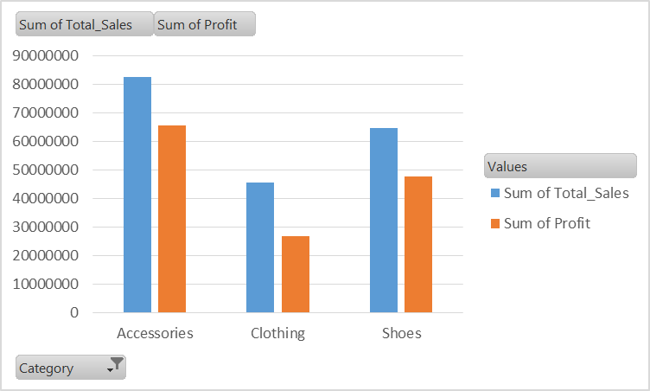

Analysis:
- Accessories generate the highest revenue (~₹80M) and profit (~₹65M), making them the most valuable category.
- Shoes contribute stable revenue (~₹65M) with consistent profit margins (~63%).
- Clothing generates the lowest revenue (~₹45M) and has the weakest profit margin (~43%), despite having similar units sold compared to other categories.

Core Explanation (WHY):
Clothing shows high volume but low profitability, which indicates:
- Higher cost structure or
- Heavy discounting reducing margins
At the same time, Accessories maintain strong margins and demand, making them highly efficient in converting sales into profit.
Key Insight:
Clothing is inefficient in profit generation, while accessories act as the primary profit driver.
2. Weekend vs Weekday Sales Patterns
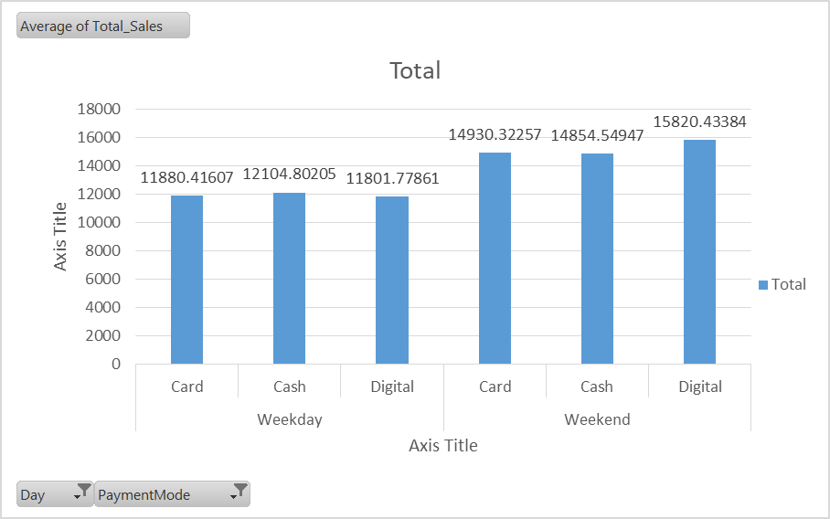

Analysis:
- Weekend AOV (~₹16,000) is significantly higher than weekday AOV (~₹12,000), indicating higher spending per customer.
- However, weekend sales volume is much lower, with a ratio of 0.52 compared to weekdays.
- Digital and card payments dominate weekend transactions, suggesting preference for seamless payment methods.

Core Explanation (WHY):
Weekend customers are high-intent buyers who spend more per transaction.
However, the lower volume indicates:
- Fewer customers visiting stores
- Possible lack of weekend promotions or engagement
Key Insight:
The problem is not low spending — it is low footfall on weekends.

3. Impact of Discounting on Profitability
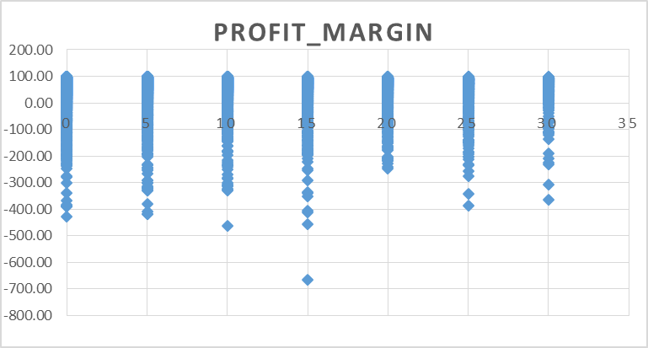

Analysis:
- Profit margin drops from 82.5% (without discount) to 72.5% (with discount)
- This results in a ₹19.36M loss in potential profit
- Some transactions show negative profit margins, meaning products are sold below cost

Core Explanation (WHY):
Discounts are applied broadly across all categories, including high-performing ones.
This leads to:
- Reduced margins on products that could sell at full price
- Loss-making transactions due to excessive discounting
Key Insight:
Discounting is being overused and poorly targeted, directly impacting profitability.

4. Store Performance Analysis

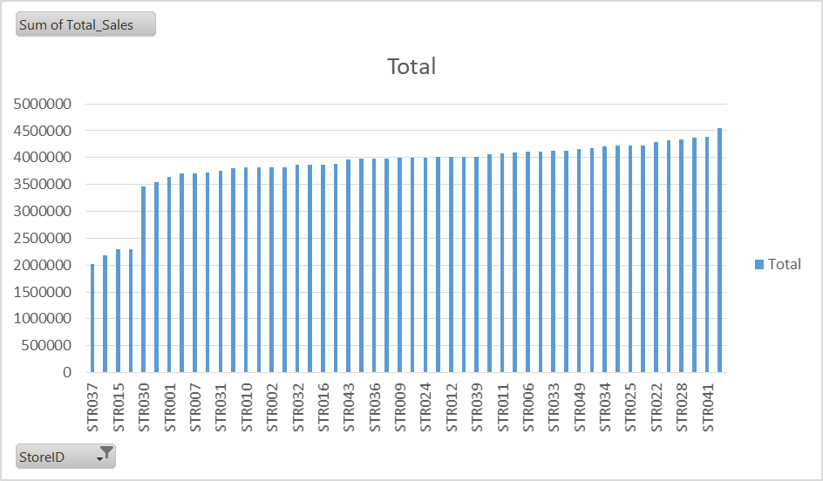

Analysis:
- Significant variation exists across stores
- Top-performing stores (e.g., STR041) generate over ₹4.5M
- Underperforming stores (e.g., STR037) generate ~₹2.01M (75% lower)
- Low-performing stores show weaker sales across all categories

Core Explanation (WHY):
Underperformance is not due to a single factor but likely due to:
- Poor product mix (less high-margin categories like Accessories)
- Lower customer footfall
- Lower conversion rates
Key Insight:
Store performance depends heavily on category mix and customer conversion efficiency.

5. Customer Segmentation
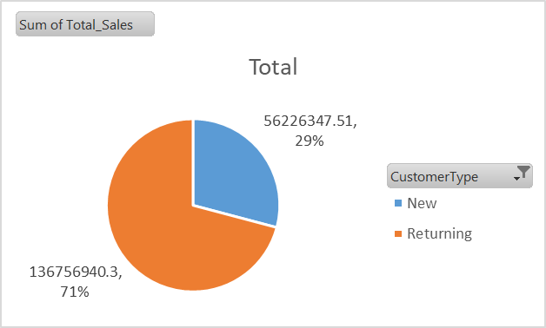
Analysis:
Customers are segmented based on purchase behavior and contribution:
- Returning Customers: Contribute ~₹136.75M (~71% of total sales), making them the primary revenue drivers
- New Customers: Contribute ~₹56.23M (~29% of total sales), indicating lower overall contribution
Behavioral segmentation:
- Digital Loyalists (Returning/Digital): High AOV (~₹13K), frequent and high-value customers
- Reliable Core (Returning/Card): Highest transaction volume and consistent contributors
- New Cash Customers: Moderate-to-high spending but limited data visibility

Core Explanation (WHY):
The data shows that returning customers dominate revenue, indicating strong customer retention and repeat purchases.
- Digital and card users are easier to track and target, enabling personalized marketing
- Cash users remain largely untracked, limiting engagement opportunities
- New customers contribute less, suggesting a gap in acquisition or conversion
Key Insight:
Returning customers contribute over 70% of total revenue, highlighting strong loyalty; however, improving new customer acquisition and conversion is essential for long-term growth.

Strategic Recommendations & Execution Roadmap

Immediate Actions (0–30 Days)
- Selective Margin Recovery: Remove unnecessary discounts on Accessories → Recover ₹19.36M profit loss
- Sunday “Golden Hour” Sales: Time-bound discounts on Clothing → Boost weekend sales without margin impact
- Cross-Category Bundling: Combine Clothing + Accessories → Increase AOV & improve low-performing category

Mid-Term Strategies (30–90 Days)
- Loyalty Migration Campaign: “3x Weekend Points” → Shift weekday customers to weekends
- Store Optimization (“Blueprint Model”): Replicate STR041 → Improve underperforming store sales
- Product Mix Improvement: Focus on high-margin categories → Increase profitability
- Customer Data Capture: Convert cash users to digital → Enable targeted marketing

Long-Term Strategy (6 Months+)
- Dynamic Pricing Model: Demand-based discounting → Optimize margins & reduce over-discounting
- Omnichannel Integration: “Click & Collect” + online offers → Increase weekend footfall
- Digital Engagement Focus: Leverage high AOV users → Drive higher-value transactions

